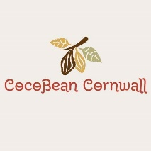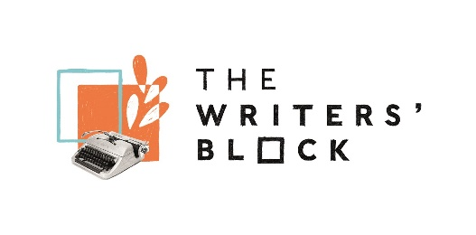

**Imagine**

***Collecting and celebrating stories from our Global Majority community***

The Writers’ Block alongside Cocobean Cornwall is inviting four Year 5 classes in Camborne/Redruth to be part of this important project uncovering the life stories of some of our global majority community members through creative writing and live interview.

The vision for this project is to celebrate and increase awareness of the lives and heritage of the Global Majority community in Cornwall and showcase it at The Writers’ Block, alongside stories of other Cornish communities that we already hold.

We have 12 community members from India, Burma, Polynesia and Fiji who are excited about sharing elements of their personal stories of living and working in Cornwall with the children.

Each Year 5 class will be partnered with 3 community members (10 pupils per individual)

**The project will include:**

* Anti Racism Training from Black Voices Cornwall for teachers and project team
* One Black History in Cornwall workshop at Kresen Kernow for each class
* Two creative writing workshops in school for each class
* One interview techniques workshop in school for each class
* One live interview event at The Writers’ Block for each class
* A final celebratory event at The Writers’ Block for each class

**Timeline**

|  |  |
| --- | --- |
| **Date** | **Activity** |
| Mon 25 Nov 4-5.30pm | Schools planning meeting at The Writers’ Block |
| TBC December | Anti-racism training (optional) |
| 13 Jan-17 Jan 2025 | Black History school workshops at Kresen Kernow (2hrs) |
| 20 Jan-13 Feb 2025 | 2 x 2hr Creative writing workshops in each of 4 schools |
| 24 -28 Feb 2025 | 1 x 2hr Interview techniques workshops in each of 4 schools |
| 3 – 7 March 2025 | Interview events where children meet community members at The Writers’ Block (2hrs) |
| 31 March-4 Apr | Opening private view of exhibition. Two sessions in one day, 60 children per session. (1hr) |

Participating schools undertake to:

* Engage in regular communication with the project team
* Attend planning meetings
* Identify a lead teacher for the project and support them to take part
* Enable the teachers and class to attend the out of school workshops
* Support the booking and delivery of the in-school workshops
* Facilitate the completion of the parental permission forms for each pupil
* Provide a project contribution of £50 per class involved

Note: The project budget includes funds to support transport to the out of school workshops.

If your school would like to be involved in the project, please email Grace Davies [grace.davies@keap.org.uk](mailto:grace.davies@keap.org.uk) with the following:

* Your school name and location
* The number of Year 5 classes who would like to take part
* How many pupils from the global majority / mixed heritage are in each class (this is essential so we can be sure to support them properly)
* Why you think this project will benefit your school, teachers and pupils.
* State that you have reviewed the timeline and project details contained in this document and envisage being able to take part on this basis.

**Please respond by a deadline of Monday 18 November at 5pm.**

**We will let your school know if they have been selected on Wed 20 November**

**Note that the initial schools planning meeting is on Monday 25 November 4-5.30pm at The Writers’ Block in Redruth and it is essential that a member of staff attends.**

**Project Detail**

**Black History in Cornwall workshops**

The project will begin by each class having a Black History in Cornwall workshop at Kresen Kernow, This will give the children an historical context for the more contemporary lives they will encounter.

Workshops will be led by Bev Bevington, Black community leader and founder of Cocobean, and Chloe Phillips, PhD in Black History in Cornwall and former education lead at Kresen Kernow.

**Kresen Kernow workshops will take place on 14, 15, 16 January 2025 and be either morning or afternoon.**

**Creative Writing workshops**

The two workshops in school will explore various avenues of creative writing - from poetry to life writing - using personal objects provided by our global majority community participants as inspiration. Through a range of techniques such as metaphor, personification and descriptive language, students will embark on fun, empowering and dynamic creative writing workshops, to look at both the similarities and differences we all share.

Each class will be partnered with 3 community members (10 children per individual) At this point, the children will not know anything about the individuals to whom the objects belong. Through the workshops, the children will also begin to look at what questions they might want to ask the owners of these objects to discover more about their lives.

Creative writing workshops will be led by writer and poet Rebecca Tantony.

**Creative writing workshops will take place on Mondays and Fridays between 20 Jan and 14 Feb. They will be 2 hrs duration and may be mornings or afternoons.**

**Interview techniques workshops**

There will be a further in-school workshop where the children will learn live interview techniques – how to phrase questions to elicit the most open answers and how to use the recording equipment.

Interview techniques workshops will be led by Leo Devine (broadcaster, lecturer and former head of BBC South West), and Matt Aye-Pe (BBC Radio Cornwall)

**Interview techniques workshops will take place between 24-28 February. They will be 2 hrs duration and may be mornings or afternoons.**

**Live interview sessions**

We will then host a live interview session at The Writers’ Block where the children will meet the community members they have been partnered with. The children will interview the individual and create live recordings of these interviews. These will be edited and form part of an exhibition at The Writers’ Block, and passed to Kresen Kernow for archiving in perpetuity.

Each group of 10 children will be in a separate space at The Writers’ Block to undertake the interview with their community member. The community members will have been briefed on how to respond to the children’s questions, and to ensure that responses are appropriate. We will ensure we have plenty of staff to support this, and recommend that each school bring 3 members of staff.

**Live interview sessions will take place 3-7 March at The Writers’ Block. They will be approx 1.5 hrs duration and may be mornings or afternoons.**

**Celebration Event**

Finally, we will host a celebration event and private view bringing the community members and schools together again, to see the resulting exhibition, listen to the recorded interviews and have some cake! We expect each celebration event to be for 2 classes (60 children) and 6 community members.

**Celebration events will take place 31 March – 4 April at The Writers’ Block and will be approx 1.5 hrs duration.**

